Project Plan
Quality of life assessment through smart video monitoring
The project plan describes a system that can track plus live update data on a person's activity and complete a life assessment on said individual. This is to hopefully increase an elderly person's survivability since declining exercise rates are liked with health loss.
The goal is to increase life expectancy in elderly individuals and give live health reports to said elderly person or possibly a carer/doctor to possibly increase aid or give them a plan to increase health.
Our objectives as a group are
- Achieve a functional prototype showing smart video monitoring
- Be able to track daily routines and show insights into daily activates
- Create a foundation for a future complete design (multi-sensor integration)
- Recognize activities such as walking, standing, sitting and falling
- Create a system where carers and doctors can monitor wellbeing
When looking at the scope of this project, it is important to understand that this is to create a prototype, not a fully functioning system. This should be the base which can be added to in the future.
I would suggest we exclude focusing on a specific ui design and create something simple and focusing on the backend since this is something which is likely to be far more important than having a flashy ui with no fictionality.
Project Team
Ethan Hunt Computer Science (Software engineering)
Dylan Shirley Computer Science (Software engineering)
Finlay Jackman Computer Science (Software engineering)
Taiyo Kinoshita Computer Science (Artificial Intelligence)
Term 1: TimeLine
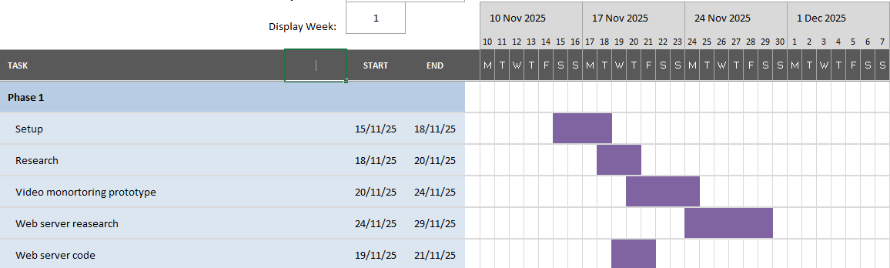
Research:
Our Basic Understanding:
So, In home monitoring is a key component in a possible future norm for elderly people it is also sometime known as Remote patient monitoring (RPM) or (Telehealth) this will allow a patient's health provider to monitor their daily health remotely and give them advice on longevity. We believe that this is a good approach to these issues since you are able to watch people with chronic conditions and if someone is living alone then they have someone to check on them this also allows for less in person waiting times and less crowded a and e visits.
It will work through multiple cameras which will be placed in unobstructive places around the house, most likely high up to avoid it being an eye sore (this will also allow a bird’s eye view of the house so if there is a fall then the system will have a better chance at picking it up).
It other systems just like this proposed plan they do also include a 2-way audio video system allowing a health care provider to talk to the patient if needed. They also include wearables which track sudden movements which could indicate a fall (this is something we may think about).
Benefits: Improved safety, quicker care in the moment, allows elderly to be more independent, allows a patient out to interact and engage with managing their own health
Issues: Costs ALOT, there is an issues with security and ethics, elderly people may find it hard to use the system
Machine Learning:
Machine learning algorithms are a class of computational methods which involve systems learning patterns from data to make predictions or decisions without explicit programming for each individual task. These algorithms represent the backbone of state-of-the-art applications in the field of artificial intelligence including recommendation systems, image recognition, natural language processing, and autonomous vehicles. While machine learning embodies quite a broad array of techniques the vast majority of algorithms fall into several broad categories supervised learning, unsupervised learning, semi-supervised learning, reinforcement learning, and deep learning. Supervised learning algorithms require labelled data every training example consists of input features and the correct output.
An algorithm learns from a mapping between inputs and outputs before being able to generalize it on new, unseen data. Popular supervised algorithms include linear regression, logistic regression, support vector machines, decision trees, random forests, and gradient boosting models. Each of these methods has different strengths: linear models are usually very interpretable, while the ensemble methods, such as random forests and boosting, are often among the best performers since they combine the outputs of many weak learners.
In contrast, unsupervised learning algorithms operate on the basis of unmarked data. Their objective is to find in a dataset either structure or hidden patterns. Methods of clustering such as k-means, hierarchical clustering, and DBSCAN, group similar data points together and thus are useful in customer segmentation, anomaly detection, and exploratory data analysis. Dimensionality reduction algorithms include principal component analysis and tSNE, which compress data into lower-dimensional forms in such a way as to preserve important relationships, enabling humans to visualize complex data more effectively and enhancing the performance of subsequent learning tasks.
Semi-supervised learning bridges the gap between these two camps by making use of a small amount of labelled data in addition to a large amount of unlabelled data. This is especially worthwhile whenever labelling is expensive or time-consuming. Pseudo-labelling and graph-based algorithms are just a few of the techniques that draw upon the structure of unlabelled data in order to enhance classification accuracy. Reinforcement learning is a different paradigm wherein an agent learns to make decisions through interactions with an environment. The agent receives rewards or penalties for certain actions and tries to maximize long-term cumulative reward. Algorithms such as Qlearning, SARSA, and policy gradient methods allow it to learn tasks from game playing to robotics. Reinforcement learning is particularly powerful when the optimal behaviour cannot be easily specified in advance but can be discovered by trial and error.
Web server:
We decided as a group that the best course of action would be to host our product on a web server before creating the server it is important to under stand that there are both positives and negatives of hosting the app in such a way, such as: there would be centralized access to the software allowing multiple people to accesses the information at once allowing it to be actively assessed, it also can be used across multiple different devices which means it can be scaled well with multiple different clients.
Even though web servers do come with a multitude of risks such as: security problems where people might be able to get in contact with the camera allowing unwanted viewing, there is also with how expensive this can be if the software was to go global we would need a large scale data centre to be able to deal with the traffic which is unlikely obtainable with the current level of the project
Proposed Solution.
Our proposed solution as a group is to have a Web based program which can use any plugged-in webcam as a video monitoring hardware. This will make it highly accessible and with a straightforward UI it means the elderly can easily set up the software leaving no place for confusion. This will help the system be implemented world-wide which means we can help many people on the process.
Using video monitoring as the main capturing software we can collect credible data from just capturing the data that the camera records live.

